**Project Communication Management**

**Communication Planning:**

Our team is made up of 4 members and is Supervised by Dr. Pranita Upadhyaye ,total communication channel will be 6 : (n(n-1)/2)

**Sample Stakeholders Communication analysis:**

Communication will be in accordance of stakeholders tasks and concerns , flow of communication will be according to respective document presented

| **Stakeholders** | **Document Name** | **Document Format** | **Contact Person** | **Due** |
| --- | --- | --- | --- | --- |
| Customer Management and communication with Supervisor | Weekly Status Report | Hard Copy | Rajiv Dahal | First of week |
| Voice to text and Its data collection | Weekly Status Report | Hard Copy | Rabin Timalsina | First of week |
| Image processing and and data collection | Weekly Status Report | Hard Copy | Samrat Neupane | First of week |
| Web site creation and deployment | Weekly Status Report | Hard Copy | Sameep Dhakal | First of week |

**Media Choice Table**

Way of communication is verified and chosen according to following table

**key:1 =Excellent 2=Adequate 3=Inappropriate**

| **How well medium is suited to:** | **Hard Copy** | **Messenger** | **Voice Mail** | **E-mail** | **Zoom meeting** | **github** |
| --- | --- | --- | --- | --- | --- | --- |
| Assessing Commitment | 3 | 3 | 3 | 3 | 1 | 3 |
| Programming Help | 3 | 1 | 3 | 2 | 2 | 3 |
| Resolving Misunderstanding | 3 | 2 | 1 | 3 | 3 | 3 |
| Maintaining Confidentiality | 2 | 2 | 1 | 2 | 3 | 3 |
| Sharing code | 3 | 2 | 3 | 2 | 3 | 1 |
| Building logics and modifying plans | 3 | 2 | 1 | 2 | 1 | 3 |

**Conclusion:**

Assessing Commitment via Zoom meeting,Programming Help via Messenger,Resolving Misunderstanding via voicemail,Maintaining Confidentiality via voice mail,v via github,Building logics and modifying plans via Zoom meeting

**Traceability Matrix:**

Requirements traceability is the ability to connect requirements to other artifacts — such as different [types of software tests](https://www.perforce.com/resources/alm/types-software-testing) or bugs. It's used to track requirements — and prove that requirements have been fulfilled.

| **Ref. id** | **Main Requirement** | **Sub Requirement** | **Category** | **Description** | **Team** | **Status** | **Non functional requirement** |
| --- | --- | --- | --- | --- | --- | --- | --- |
| 1 | Voice to text and Image subtraction datasets preparation | Data cleaning and documentation | required | Through kaggle or manual preparation | Rabin,  Rajiv- Sameep Samrat | Started  (work in progress) | Usability, reusability,stability,availability |
| 2 | Data training and model preparation | Make exportable and reusable model | required | Using Sklearn libraries and tensor flow | Rabin,Rajiv-Sameep Samrat | to-do | Performance,Security,Usability,Portability,Availability |
| 3 | UI/UX design and front end development | Component based development | required | Use Reactjs and photoshop | Rabin,Rajiv-Sameep Samrat | Started  (work in progress) | Usability, reusability,stability,availability |
| 4 | Api creation and data modeling | Should be based on Rest API | required | Use Nodejs and mongoDB | Rabin,Rajiv-Sameep Samrat | to-do | Performance,Security,Usability,Portability,Availability |
| 5 | Deployment | Use Heroku | optional | Use git and its tool | procurement | to-do | Performance,Security,Usability,Portability,Availability |
| 6 | SEO optimization | Use MOz-pro | optional | Optional can be done in spare time | procurement | to-do | performance,Availability,Usability |

# **Procurement Management Plan**

Procurement itself defines the materials or resources to purchase and acquire from outside the project team. Our team has concluded different resources to procure which are briefly listed and explained in the document below

**Process flow**

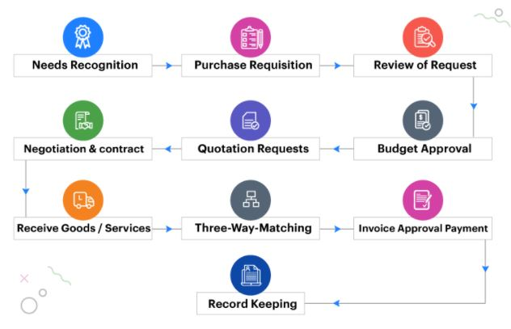

**Procurement document with responsible Authority**

Project Name:Intelligent Re-commerce site with Image and voice processing

*Date: 24th July 2021*

| **Description** | **Type** | **Reason** | **Timing to start** | **Bidder** | **Status** | **Comments** |
| --- | --- | --- | --- | --- | --- | --- |
| SEO specialist | technical | To perform SEO after deployment | 20 Dec 2021 | Er. Umesh Baral | informed | Project will be given to SEO specialist on 10-10-2021 |
| Data training Server | Resource | To train AI model | 15 Aug 2021 | Team members, AWS server | informed | Datasets will be ready and one time agreement |
| Domain and Hosting | Resource | To deploy and launch software | 22 Dec 2021 | Er. Umesh Baral,server | to-do | Software will be ready and must have fulfilled functional requirements |
| Testing and QA team | Technical | To test software and analyze its quality | 15 Nov 2021 | Er. Pranish Deuja and team | informed | Software will be ready and should be in final stage to launch |
| Database Administrator | Technical | To extract necessary Info. and maintain database | 1st Jan 2022 | Ritika Giri and team | informed | Must have logged in user info and traffic data and should submit analytical report to CEO |